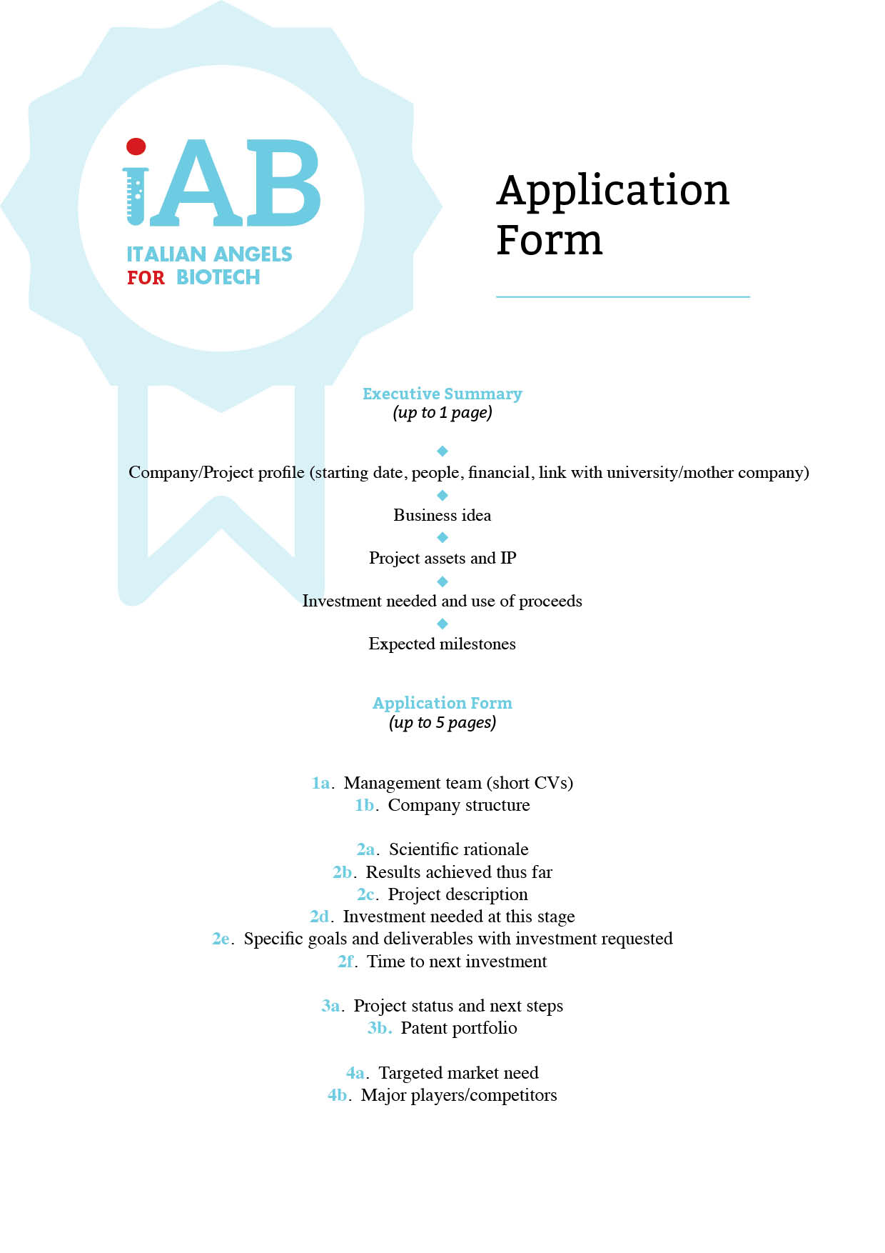
T

Executive Summary

Write your info below

Application Form
(Maximum 5 pages)

Please always refer to the index:

es.
1a. Write your text here…

1b. Write your text here…

